**Assignment-5: Implementation of MapReduce algorithm for Matrix Multiplication.**

**Chaitanya Sai Nutakki  
AP21110010253**

**GETTING JAR FILE TO ROOT DIRECTORY**

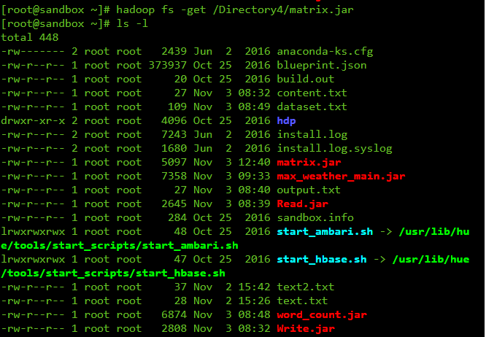

**RUNNING THE MATRIX JAR FILE**

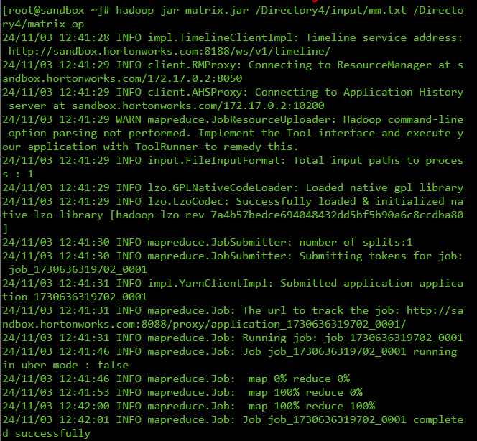

**FILE PREVIEW**

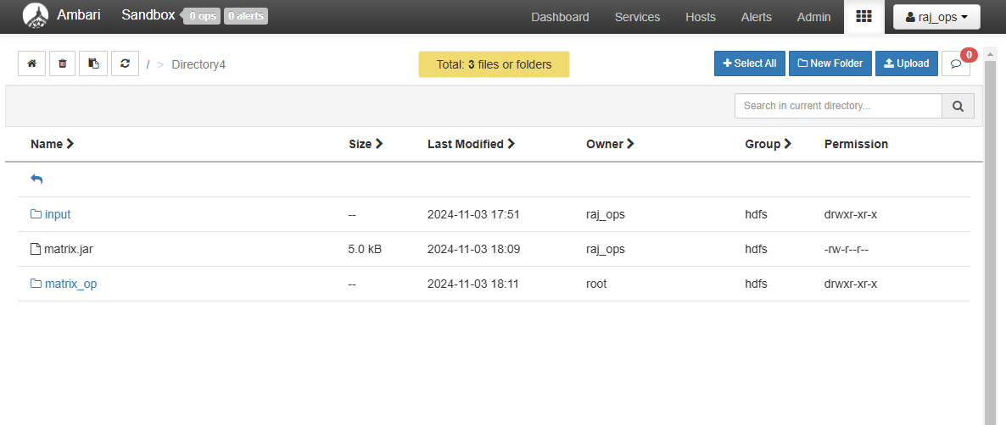

**INPUT TEXT FILE**

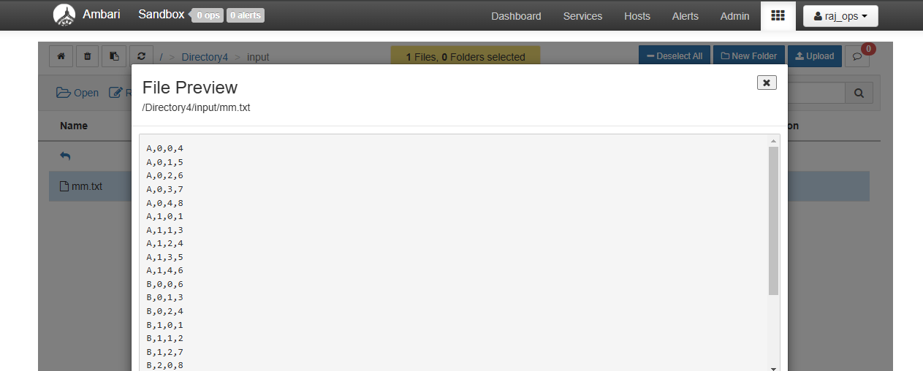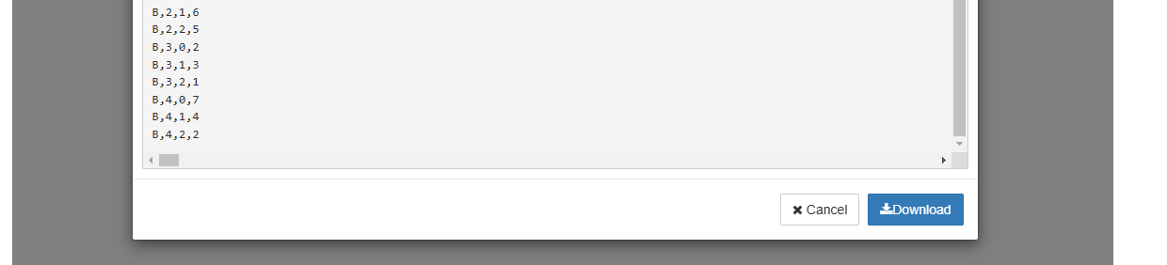

**OUTPUT TEXT FILE**

